OSPF EIGRP Redistribution

# CCNP Lab 11

## Axel Li

## 30 May 2019

# Purpose

The purpose of the lab was to review the fundamentals of routing protocol distribution with EIGRP and OSPF. Our task was to redistribute two OSPF routing processes and an EIGRP routing process such that the router at the very end could ping the internet, simulated by a loopback interface (see topology diagram below). In addition, we had to redistribute routes to have an interior AD of 90, exterior AD of 105, reliability of 245, and delay of 900.

# Background

Route redistribution is the process where different routing protocols on a device share their routing information with each other. Without route distribution, all devices in a network would need to run the same routing process and, for large networks, would each have a large topology table. In addition, different networks running different protocols would be unable to communicate without route redistribution.

When redistributing routes, network administrators must define the metrics to be used by the routing protocol receiving the route. EIGRP in particular uses five K values with the formula:

metric = 256 * ({(K1*BW) + [(K2*BW)/(256-LOAD)] + (K3*DELAY)} * (K5/(REL+K4)))

By tweaking the K values, network administrators can influence which routes EIGRP will calculate to be the best.

|  |  |
| --- | --- |
| K Value | Attribute |
| K1 | Bandwidth |
| K2 | Load |
| K3 | Delay |
| K4 | Reliability |
| K5 | Reliability |

# Summary

When first starting, my partner and I wrote a configuration for each of the devices on a separate text file with basic redistribution. We then pasted the configurations into each router and confirmed that the routers could ping each other and the loopback interface throughout the network. We then researched how to redistribute routes with custom attributes and influence the metric and made corresponding changes to the router configurations. Afterwards, we used show ip protocol, show ip route, and show ip eigrp topology to verify that the correct K values and administrative distances were shown.

# Commands

The key commands used in this lab for the router were:

metric weights [type of service (0-8)] [k1 (0-255; default 1)] [k2 (0-255; default is 0)] [k3 (1-255; default is 1)] [k4 (0-255; default is 0)] [k5 (0-255; default is 0)] - tunes EIGRP metric calculations to specified values and indicates the type of service, allows for varying routing behaviors

distance eigrp [internal distance] [external distance] – sets the internal and external administrative distances

redistribute protocol [ process-id ] { level-1 | level-1-2 | level-2 } [ autonomous-system-number ] [ metric { metric-value | transparent } ] [ metric-type type-value ] [ match { internal | external 1 | external 2 } ] [ tag tag-value ] [ route-map map-tag ] [subnets] [nssa-only] - redistributes routes from one routing domain into another routing domain.

# Tables and Diagrams.

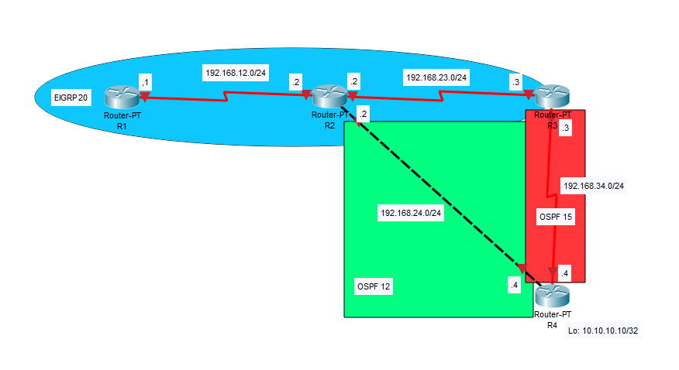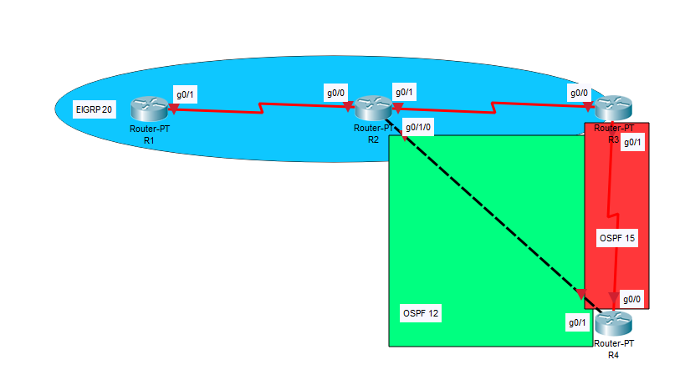

# Configurations

**Router 4:**

R4#show ip protocols

*** IP Routing is NSF aware ***

Routing Protocol is "ospf 15"

Outgoing update filter list for all interfaces is not set

Incoming update filter list for all interfaces is not set

Router ID 10.10.10.10

It is an autonomous system boundary router

Redistributing External Routes from,

ospf 12, includes subnets in redistribution

Number of areas in this router is 1. 1 normal 0 stub 0 nssa

Maximum path: 4

Routing for Networks:

10.10.10.10 0.0.0.0 area 0

192.168.34.0 0.0.0.255 area 0

Routing Information Sources:

Gateway Distance Last Update

192.168.34.3 110 00:06:08

Distance: (default is 110)

Routing Protocol is "ospf 12"

Outgoing update filter list for all interfaces is not set

Incoming update filter list for all interfaces is not set

Router ID 192.168.34.4

It is an autonomous system boundary router

Redistributing External Routes from,

ospf 15, includes subnets in redistribution

Number of areas in this router is 1. 1 normal 0 stub 0 nssa

Maximum path: 4

Routing for Networks:

10.10.10.10 0.0.0.0 area 0

192.168.24.0 0.0.0.255 area 0

Routing Information Sources:

Gateway Distance Last Update

192.168.24.2 110 00:06:14

Distance: (default is 110)

R4#show ip route

Gateway of last resort is not set

10.0.0.0/32 is subnetted, 1 subnets

C 10.10.10.10 is directly connected, Loopback0

O E2 192.168.12.0/24 [110/20] via 192.168.34.3, 00:05:56, GigabitEthernet0/0

O E2 192.168.23.0/24 [110/20] via 192.168.24.2, 00:09:52, GigabitEthernet0/1

192.168.24.0/24 is variably subnetted, 2 subnets, 2 masks

C 192.168.24.0/24 is directly connected, GigabitEthernet0/1

L 192.168.24.4/32 is directly connected, GigabitEthernet0/1

192.168.34.0/24 is variably subnetted, 2 subnets, 2 masks

C 192.168.34.0/24 is directly connected, GigabitEthernet0/0

L 192.168.34.4/32 is directly connected, GigabitEthernet0/0

R4#show run

Building configuration...

Current configuration : 1840 bytes

Last configuration change at 19:00:03 UTC Fri Jun 14 2019

version 15.2

service timestamps debug datetime msec

service timestamps log datetime msec

no service password-encryption

hostname R4

interface Loopback0

ip address 10.10.10.10 255.255.255.255

interface GigabitEthernet0/0

ip address 192.168.34.4 255.255.255.0

duplex auto

speed auto

interface GigabitEthernet0/1

ip address 192.168.24.4 255.255.255.0

duplex auto

speed auto

router ospf 15

redistribute ospf 12 subnets

network 10.10.10.10 0.0.0.0 area 0

network 192.168.34.0 0.0.0.255 area 0

default-information originate

router ospf 12

redistribute ospf 15 subnets

network 10.10.10.10 0.0.0.0 area 0

network 192.168.24.0 0.0.0.255 area 0

default-information originate

line con 0

line aux 0

line 2

no activation-character

no exec

transport preferred none

transport output lat pad telnet rlogin lapb-ta mop udptn v120 ssh

stopbits 1

line vty 0 4

login

transport input all

scheduler allocate 20000 1000

end

**Router 3:**

R3#show ip protocols

*** IP Routing is NSF aware ***

Routing Protocol is "eigrp 20"

Outgoing update filter list for all interfaces is not set

Incoming update filter list for all interfaces is not set

Default networks flagged in outgoing updates

Default networks accepted from incoming updates

Redistributing: ospf 15

EIGRP-IPv4 Protocol for AS(20)

Metric weight K1=1, K2=1, K3=90, K4=245, K5=0

NSF-aware route hold timer is 240

Router-ID: 192.168.34.3

Topology : 0 (base)

Active Timer: 3 min

Distance: internal 90 external 105

Maximum path: 4

Maximum hopcount 100

Maximum metric variance 1

Automatic Summarization: disabled

Maximum path: 4

Routing for Networks:

192.168.23.0

Routing Information Sources:

Gateway Distance Last Update

192.168.23.2 90 00:01:29

Distance: internal 90 external 105

Routing Protocol is "ospf 15"

Outgoing update filter list for all interfaces is not set

Incoming update filter list for all interfaces is not set

Router ID 192.168.34.3

It is an autonomous system boundary router

Redistributing External Routes from,

eigrp 20, includes subnets in redistribution

Number of areas in this router is 1. 1 normal 0 stub 0 nssa

Maximum path: 4

Routing for Networks:

192.168.34.0 0.0.0.255 area 0

Routing Information Sources:

Gateway Distance Last Update

10.10.10.10 110 00:01:30

Distance: (default is 110)

R3#show ip route

Gateway of last resort is not set

10.0.0.0/32 is subnetted, 1 subnets

O 10.10.10.10 [110/2] via 192.168.34.4, 00:05:13, GigabitEthernet0/1

D 192.168.12.0/24

[90/48650] via 192.168.23.2, 00:01:15, GigabitEthernet0/0

192.168.23.0/24 is variably subnetted, 2 subnets, 2 masks

C 192.168.23.0/24 is directly connected, GigabitEthernet0/0

L 192.168.23.3/32 is directly connected, GigabitEthernet0/0

D EX 192.168.24.0/24

[105/2608640] via 192.168.23.2, 00:04:57, GigabitEthernet0/0

192.168.34.0/24 is variably subnetted, 2 subnets, 2 masks

C 192.168.34.0/24 is directly connected, GigabitEthernet0/1

L 192.168.34.3/32 is directly connected, GigabitEthernet0/1

R3#show run

Building configuration...

Current configuration : 1790 bytes

Last configuration change at 19:39:36 UTC Fri Jun 14 2019

version 15.2

service timestamps debug datetime msec

service timestamps log datetime msec

no service password-encryption

hostname R3

interface GigabitEthernet0/0

ip address 192.168.23.3 255.255.255.0

duplex auto

speed auto

interface GigabitEthernet0/1

ip address 192.168.34.3 255.255.255.0

duplex auto

speed auto

router eigrp 20

metric weights 0 1 1 90 245 0

network 192.168.23.0

redistribute ospf 15 metric 10000 90 245 255 1500

distance eigrp 90 105

router ospf 15

redistribute eigrp 20 subnets

network 192.168.34.0 0.0.0.255 area 0

line con 0

line aux 0

line 2

no activation-character

no exec

transport preferred none

transport output lat pad telnet rlogin lapb-ta mop udptn v120 ssh

stopbits 1

line vty 0 4

login

transport input all

!

scheduler allocate 20000 1000

!

End

**Router 2:**

R2#show ip protocols

*** IP Routing is NSF aware ***

Routing Protocol is "eigrp 20"

Outgoing update filter list for all interfaces is not set

Incoming update filter list for all interfaces is not set

Default networks flagged in outgoing updates

Default networks accepted from incoming updates

Redistributing: ospf 12

EIGRP-IPv4 Protocol for AS(20)

Metric weight K1=1, K2=1, K3=90, K4=245, K5=0

NSF-aware route hold timer is 240

Router-ID: 192.168.24.2

Topology : 0 (base)

Active Timer: 3 min

Distance: internal 90 external 105

Maximum path: 4

Maximum hopcount 100

Maximum metric variance 1

Automatic Summarization: disabled

Maximum path: 4

Routing for Networks:

192.168.12.0

192.168.23.0

Routing Information Sources:

Gateway Distance Last Update

192.168.12.1 90 00:00:34

192.168.23.3 90 00:00:39

Distance: internal 90 external 105

Routing Protocol is "ospf 12"

Outgoing update filter list for all interfaces is not set

Incoming update filter list for all interfaces is not set

Router ID 192.168.24.2

It is an autonomous system boundary router

Redistributing External Routes from,

eigrp 20, includes subnets in redistribution

Number of areas in this router is 1. 1 normal 0 stub 0 nssa

Maximum path: 4

Routing for Networks:

192.168.24.0 0.0.0.255 area 0

Routing Information Sources:

Gateway Distance Last Update

192.168.34.4 110 00:00:35

Distance: (default is 110)

R2#show ip route

Gateway of last resort is not set

10.0.0.0/32 is subnetted, 1 subnets

D EX 10.10.10.10

[105/2608640] via 192.168.23.3, 00:04:07, GigabitEthernet0/1

192.168.12.0/24 is variably subnetted, 2 subnets, 2 masks

C 192.168.12.0/24 is directly connected, GigabitEthernet0/0

L 192.168.12.2/32 is directly connected, GigabitEthernet0/0

192.168.23.0/24 is variably subnetted, 2 subnets, 2 masks

C 192.168.23.0/24 is directly connected, GigabitEthernet0/1

L 192.168.23.2/32 is directly connected, GigabitEthernet0/1

192.168.24.0/24 is variably subnetted, 2 subnets, 2 masks

C 192.168.24.0/24 is directly connected, GigabitEthernet0/1/0

L 192.168.24.2/32 is directly connected, GigabitEthernet0/1/0

D EX 192.168.34.0/24

[105/2608640] via 192.168.23.3, 00:04:07, GigabitEthernet0/1

R2#show run

Building configuration...

Current configuration : 2021 bytes

Last configuration change at 19:45:24 UTC Fri Jun 14 2019

version 15.2

service timestamps debug datetime msec

service timestamps log datetime msec

no service password-encryption

hostname R2

interface GigabitEthernet0/0

ip address 192.168.12.2 255.255.255.0

ip broadcast-address 192.168.12.0

duplex auto

speed auto

interface GigabitEthernet0/1

ip address 192.168.23.2 255.255.255.0

ip broadcast-address 192.168.23.0

duplex auto

speed auto

interface GigabitEthernet0/1/0

ip address 192.168.24.2 255.255.255.0

ip broadcast-address 192.168.24.0

duplex auto

speed auto

router eigrp 20

metric weights 0 1 1 90 245 0

network 192.168.12.0

network 192.168.23.0

redistribute ospf 12 metric 10000 90 245 255 1500

distance eigrp 90 105

router ospf 12

redistribute eigrp 20 subnets

network 192.168.24.0 0.0.0.255 area 0

line con 0

line aux 0

line 2

no activation-character

no exec

transport preferred none

transport output lat pad telnet rlogin lapb-ta mop udptn v120 ssh

stopbits 1

line vty 0 4

login

transport input all

scheduler allocate 20000 1000

end

**Router 1:**

R1#show ip protocols

*** IP Routing is NSF aware ***

Routing Protocol is "eigrp 20"

Outgoing update filter list for all interfaces is not set

Incoming update filter list for all interfaces is not set

Default networks flagged in outgoing updates

Default networks accepted from incoming updates

EIGRP-IPv4 Protocol for AS(20)

Metric weight K1=1, K2=1, K3=90, K4=245, K5=0

NSF-aware route hold timer is 240

Router-ID: 192.168.12.1

Topology : 0 (base)

Active Timer: 3 min

Distance: internal 90 external 105

Maximum path: 4

Maximum hopcount 100

Maximum metric variance 1

Automatic Summarization: disabled

Maximum path: 4

Routing for Networks:

192.168.12.0

Routing Information Sources:

Gateway Distance Last Update

192.168.12.2 90 00:03:18

Distance: internal 90 external 105

R1#show ip route

Gateway of last resort is not set

10.0.0.0/32 is subnetted, 1 subnets

D EX 10.10.10.10

[105/2631680] via 192.168.12.2, 00:03:00, GigabitEthernet0/1

192.168.12.0/24 is variably subnetted, 2 subnets, 2 masks

C 192.168.12.0/24 is directly connected, GigabitEthernet0/1

L 192.168.12.1/32 is directly connected, GigabitEthernet0/1

D 192.168.23.0/24

[90/48650] via 192.168.12.2, 00:03:09, GigabitEthernet0/1

D EX 192.168.24.0/24

[105/2608640] via 192.168.12.2, 00:10:36, GigabitEthernet0/1

D EX 192.168.34.0/24

[105/2631680] via 192.168.12.2, 00:03:00, GigabitEthernet0/1

R1#show run

Building configuration...

Current configuration : 1637 bytes

Last configuration change at 20:42:54 UTC Fri Jun 14 2019

version 15.2

service timestamps debug datetime msec

service timestamps log datetime msec

no service password-encryption

hostname R1

interface GigabitEthernet0/1

ip address 192.168.12.1 255.255.255.0

duplex auto

speed auto

router eigrp 20

metric weights 0 1 1 90 245 0

network 192.168.12.0

distance eigrp 90 105

line con 0

line aux 0

line 2

no activation-character

no exec

transport preferred none

transport output lat pad telnet rlogin lapb-ta mop udptn v120 ssh

stopbits 1

line vty 0 4

login

transport input all

scheduler allocate 20000 1000

end

Proof of Delay and Reliability:

R2#show ip eigrp topology 192.168.24.0

EIGRP-IPv4 Topology Entry for AS(20)/ID(192.168.24.2) for 192.168.24.0/24

State is Passive, Query origin flag is 1, 1 Successor(s), FD is 93

Descriptor Blocks:

0.0.0.0, from Redistributed, Send flag is 0x0

Composite metric is (93/0), route is External

Vector metric:

Minimum bandwidth is 10000 Kbit

Total delay is 900 microseconds

Reliability is 245/255

Load is 255/255

Minimum MTU is 1500

Hop count is 0

Originating router is 192.168.24.2

External data:

AS number of route is 12

External protocol is OSPF, external metric is 0

Administrator tag is 0 (0x00000000)

# Problems

The main problem encountered in this lab was simply figuring out how to redistribute routes with the desired attributes and modify K values. This took us a bit of time to figure out which specific commands were necessary to configure and verify the desired results. The K values and EIGRP metric formula were somewhat abstract and difficult to interpret, such as the K3 value being multiplied by 10, but we eventually figured it out through cross-referencing online manuals. The rest of the redistribution lab was simple and straightforward due to us already having experience with configuring such a network.

# Conclusion

This lab was a quick refresh of redistribution concepts with EIGRP and OSPF. We were able to review the importance of the metric weights for different protocols and adjust the weights as necessary for a network. Overall, it was a valuable renewal of route redistribution, an important, relevant technology commonly used within networks.